Direction Cosine Matrix
Rigid body orientations are described using displacements of body fixed reference frames. The reference frame itself is usually defined using a set of three orthogonal, right-hand unit vectors.
typically the reference frame base vectors are chosen such that they are aligned with the principal body axes.
The reference frame B can be thought of as being a generic rigid body, and the reference frame N could
be associated with some particular inertial coordinate system. Let the three angles a1i be the angles formed between the first body vector b1 and the
three inertial axes n1, n2, and n3. The cosines of these angles are called the direction cosines of b1 relative to the N frame.

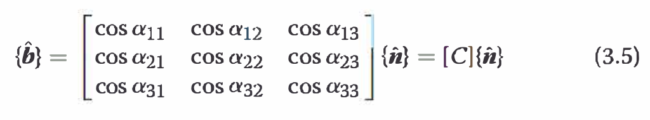

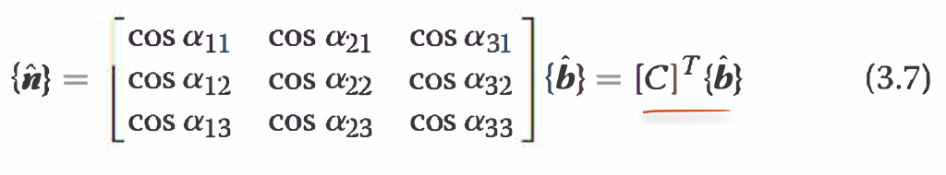
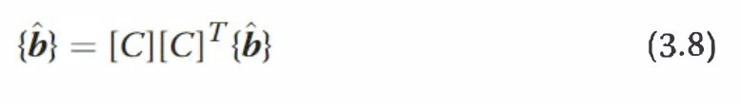
Thanks to the orthogonality of the direction cosine matrix [ C], we will see in the following that the forward and inverse transformation (projection) of vectors between rotationally displaced reference frames can be accomplished without arithmetic. Another important property of the direction cosine matrix is that its
determinant is ± 1.

if the reference frame base vectors {b} and {n} are right-handed, then det(C) = +l. Goldstein also shows that the 3x 3 direction cosine matrix [C] will have only one real eigenvalue of + 1.
Again, it will be + 1 if the reference frame base vectors are right-handed.

the most powerful feature of the direction cosine is the ability to directly project ( or transform) an arbitrary vector, with components written in one reference frame, into a vector with components
written in another reference frame.

several cascading reference frames are present where each reference frame orientation is defined relative to the previous one, and it is desired to replace the sequence of projections by a single
projection. Let {r} contain the base vectors of the reference frame R whose relative orientation to the B frame is given through [ C':

The direct transformation matrix from
the first to the last cascading reference frame is clearly found by successive
matrix-multiplications of each relative transformation matrix in reverse
order as just shown. This property [ C"] = [ C'] [ C] for composition of successive
rotations is very important. When rotational coordinates are introduced
to parameterize the [ C] matrix, the corresponding "composition" relationship
among the three sets of coordinates is also of fundamental importance.
The direction cosine matrix is the most fundamental, but highly redundant,
method of describing a relative orientation. As was mentioned
earlier, the minimum number of parameters required to describe a reference
frame orientation is three. The direction cosine matrix has nine entries. The
six extra parameters in the matrix are made redundant through the orthogonality
condition [C][C]T
= [l3x3]. This is why in practice the elements
of the direction cosine matrix are rarely used as coordinates to l<eep track
of an orientation; instead less redundant attitude parameters are used.
To find the kinematic differential equation in terms of the direction
cosine matrix [ C], let us write the instantaneous angular velocity vector w
of the B frame relative to the N frame in B frame orthogonal components
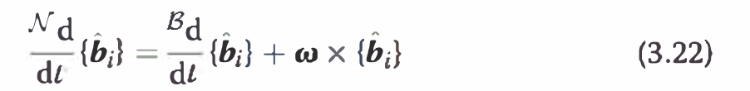

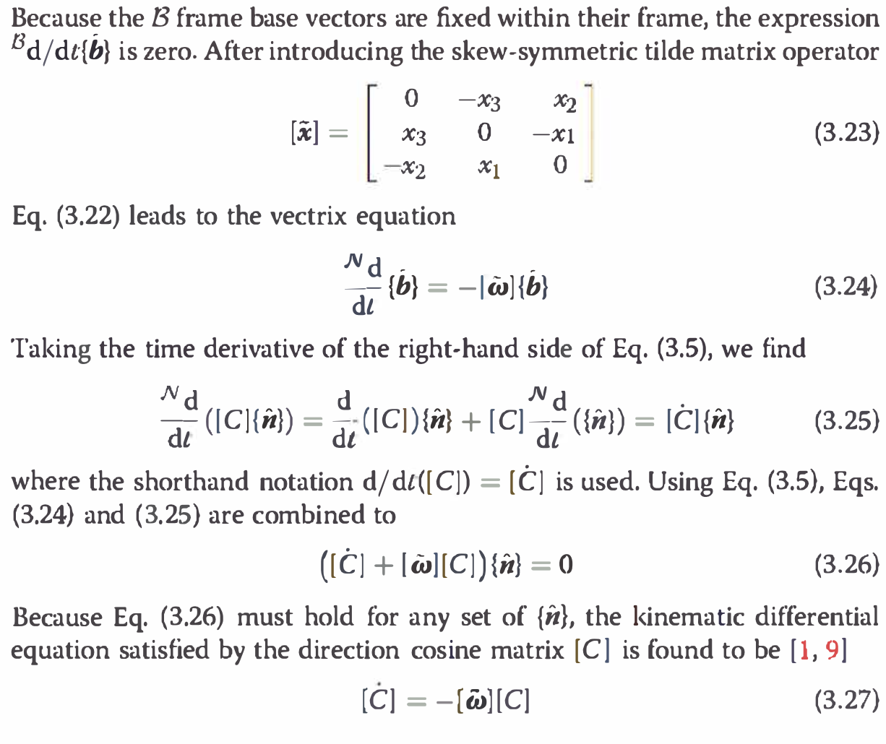

n practice,
numerical solutions of Eq. (3.27) will slowly accumulate arithmetic errors
so that the orthogonality condition [C][C]T - [13x3l = 0 is slightly in error.
There are several ways to resolve this minor difficulty.
Given an arbitrary time history of w(t), Eq. (3.27) represents a rigorously
linear differential equation that can be integrated to yield the instantaneous
direction cosine matrix [C]. A major advantage of the l<inematic differential
equation for [ C] is that it is linear and universally applicable.
There are no geometric singularities present in the attitude description or
its l<inematic differential equations. However, this advantage comes at the
cost of having a highly redundant formulation. Several other attitude parameters
will be presented in the following sections that include a minimal
number (3) of attitude parameters. However, all minimal sets of attitude
coordinates have l<inematic differential equations that contain some degree
of nonlinearity and also embody geometric and/ or mathematical singularities.
Only the once-redundant Euler parameters (the four elements of
Hamilton's quaternion) will be found to retain a singularity-free description
and possess linear l<inematic differential equations analogous to the direction
cosine matrix.

